Dynamics 365 Overview

Dynamics 365 is a comprehensive suite of cloud-based business applications developed by Microsoft. It encompasses a range of software tools designed to streamline various aspects of business operations, including customer relationship management (CRM) and enterprise resource planning (ERP). The platform is known for its flexibility, scalability, and integration capabilities, making it a popular choice for businesses of all sizes and industries.

Here are some key components of Dynamics 365:

1. **Customer Engagement (CRM)**:
   * This module focuses on managing customer interactions, sales, and marketing efforts. It helps businesses build and maintain strong relationships with their customers by providing tools for lead management, opportunity tracking, customer service, and marketing automation.
2. **Finance and Operations (ERP)**:
   * Formerly known as Dynamics AX and Dynamics NAV, this module handles core business functions like financial management, supply chain management, human resources, and manufacturing. It's designed to optimize and automate processes to improve operational efficiency.
3. **Retail**:
   * This module is tailored for businesses in the retail industry. It covers areas such as point-of-sale (POS), inventory management, customer service, and store operations, helping retailers manage their operations effectively.
4. **Talent**:
   * Dynamics 365 for Talent focuses on human resources and workforce management. It includes features for recruitment, onboarding, performance management, and employee development.
5. **Marketing**:
   * Dynamics 365 for Marketing is a powerful tool for planning and executing marketing campaigns. It offers capabilities for email marketing, lead scoring, customer journey mapping, and analytics.
6. **Customer Service**:
   * This module is dedicated to providing exceptional customer support. It includes features for case management, knowledge base management, service level agreements (SLAs), and omnichannel engagement.
7. **Field Service**:
   * Field Service is designed for businesses that manage field operations or service technicians. It helps optimize scheduling, dispatching, and managing resources in the field.
8. **Project Service Automation**:
   * This module is tailored for project-based businesses. It includes features for project planning, resource management, time and expense tracking, and billing.
9. **Mixed Reality**:
   * This is a more specialized module that leverages augmented reality (AR) and virtual reality (VR) to enhance business operations. It can be particularly useful in scenarios like remote assistance, training, and product visualization.
10. **Commerce**:
    * This module is geared towards businesses involved in e-commerce. It includes capabilities for managing online storefronts, product catalogs, and order processing.

Dynamics 365 is hosted on the Microsoft Azure cloud platform, providing users with the benefits of scalability, security, and easy integration with other Microsoft services like Office 365 and Power Platform.

The platform is designed to be highly customizable, allowing businesses to adapt it to their specific needs through configurations, extensions, and integrations. Additionally, it incorporates advanced analytics and artificial intelligence capabilities, providing insights and predictions to help businesses make informed decisions.

Overall, Dynamics 365 offers a powerful suite of tools that can drive digital transformation and improve various aspects of business operations. It's suitable for a wide range of industries and can be tailored to meet the unique requirements of individual organizations.

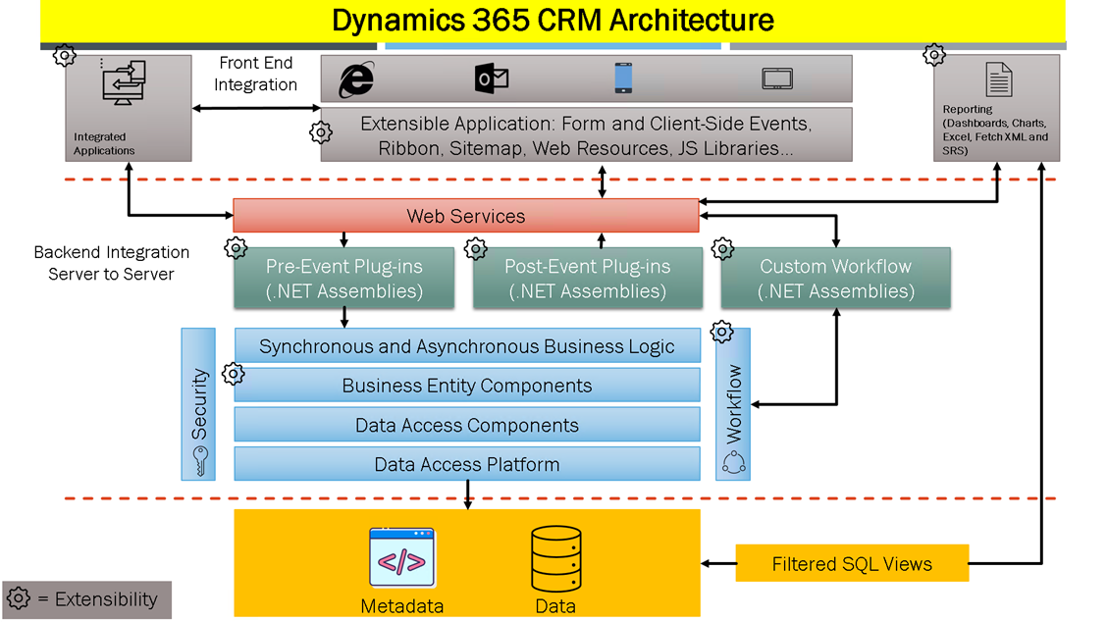Top of Form